Automatic detection of epilepsy-typical spikes in EEG and MEG

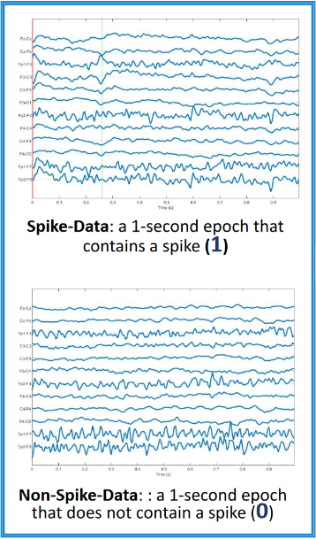
Worldwide, around fifty million people suffer from epilepsy, making it one of the most common neurological diseases globally [WHO, 2022]. The focus of this thesis project is the non-invasive diagnosis and treatment of drug-resistant focal epilepsy. In this type of epilepsy, between seizures so-called interictal epileptiform discharges (IEDs) or spikes are non-invasively measured in Electro- (EEG) and Magnetoencephalography (MEG). Spikes are travelling waves arising from an epileptogenic source, i.e., the marking of spikes and averaging over spikes of similar topography helps in determining the epileptogenic zone and thereby contributes to diagnosis and therapy of drug-resistant focal epilepsy. The marking of EEG/MEG spikes is currently done by expert markers/epileptologists, but first results of our research show that methods from artificial intelligence might be able to achieve a sensitivity and specificity that can compete with expert markers [1].
[1]
In this master thesis, we will therefore work on automatic detection of spikes using convolutional neural networks (CNN). This type of network is typically used to detect patterns in images. In this thesis, time-frequency analyses will be used as input to the CNN. In addition, feature extraction will be performed on already known features that are promising for spike detection. The extracted features can be used as additional input and thus a combination of already known features and the time-frequency analyses is used. The aim is to maximize the detection accuracy of spikes in EEG and MEG.
[1]: D Yesilbas, et al.: “Comparison of Feature Extraction Methods for Spike Detection with Artifical Neural Networks: A Focal Epilepsy Case Study”, Poster, DGBMT2023, Duisburg, Sept.2023.
Tasks:
- Feature extraction from EEG and MEG data
- Pattern recognition for spike detection
- Analysis of different machine learning methods
Requirements:
- Good knowledge in Python and digital signal processing
- Structured, independent way of working and interest in medical issues
Contact:
Prof. Dr. C. Wolters | Institut für Biomagnetismus und Biosignalanalyse  Universität Münster  E-Mail: cawolt@uni-muenster.de
Prof. Dr. G. Schmidt | Technische Fakultät  Phone: +49-431-880-6125  E-Mail: gus@tf.uni-kiel.de | M. Sc. Patricia Weede | Technische Fakultät  Phone: +49-431-880-6141  E-Mail: pp@tf.uni-kiel.de
Master thesis in Computer Science, Mathematics or Physics:
Automatic detection of epilepsy-typical spikes in EEG and MEG

